AI FRAMEWORK FOR IDENTIFYING ANOMALOUS NETWORK TRAFFIC IN MIRAI AND BASHLITE IOT BOTNET ATTACKS
ABSTRACT
In recent years, the proliferation of Internet of Things (IoT) devices has significantly increased the volume of network traffic and the complexity of network environments. According to the Global IoT Security Market Report, the number of IoT devices surged from approximately 8.4 billion in 2017 to an estimated 30.9 billion by 2025. This exponential growth has led to a corresponding rise in sophisticated network attacks, with Mirai and BASHLITE botnets being prominent examples. The Mirai botnet, which first emerged in 2016, exploited IoT vulnerabilities to launch large-scale Distributed Denial of Service (DDoS) attacks, while BASHLITE, identified in 2014, has been known for its effective use of compromised devices in various cyber-attacks. Traditional methods for detecting anomalies in network traffic typically involve manual inspection and rule-based systems. These approaches face several challenges, including the high volume of data, the dynamic nature of network traffic, and the evolving tactics of attackers. Manual methods are often labor-intensive, prone to human error, and struggle to keep pace with sophisticated attack techniques. Rule-based systems, while useful, are limited by their inability to adapt to new and previously unseen attack patterns. Machine Learning (ML) offers a promising alternative for addressing these limitations. By leveraging algorithms capable of learning from historical data and adapting to new patterns, ML models can identify anomalous traffic indicative of Mirai and BASHLITE attacks more effectively. These models can analyze vast amounts of network data in real time, detect subtle deviations from normal behavior, and improve detection accuracy over time. This approach not only enhances the ability to identify emerging threats but also reduces the dependency on manual intervention, leading to more efficient and scalable network security solutions.

CHAPTER 1
INTRODUCTION
1.1 Overview
In the contemporary digital landscape, the proliferation of Internet of Things (IoT) devices has revolutionized various industries, leading to unprecedented growth in network traffic and complexity. According to the Global IoT Security Market Report, the number of IoT devices surged from approximately 8.4 billion in 2017 to an estimated 30.9 billion by 2025. This exponential increase has simultaneously escalated the risk and frequency of sophisticated network attacks, with the Mirai and BASHLITE botnets being particularly notorious. The Mirai botnet, first identified in 2016, exploited vulnerabilities in IoT devices to orchestrate large-scale Distributed Denial of Service (DDoS) attacks, while the BASHLITE botnet, discovered in 2014, has been associated with various cyber-attacks leveraging compromised devices.
Traditional anomaly detection methods in network traffic, which often rely on manual inspection and rule-based systems, are increasingly inadequate in this evolving threat landscape. These conventional approaches face significant challenges due to the vast volume of data, the dynamic nature of network environments, and the continuously evolving tactics of attackers. Manual methods are labour-intensive, prone to human error, and struggle to keep pace with the sophistication of modern cyber threats. Rule-based systems, although useful, lack the flexibility to adapt to new and previously unseen attack patterns.
In response to these limitations, Machine Learning (ML) presents a promising solution. ML algorithms, with their capacity to learn from historical data and adapt to new patterns, offer enhanced capabilities for identifying anomalous traffic indicative of Mirai and BASHLITE botnet activities. By analysing extensive network data in real time, ML models can detect subtle deviations from normal behaviour, thereby improving detection accuracy and response times. This approach not only bolsters the ability to identify emerging threats but also minimizes reliance on manual intervention, paving the way for more efficient and scalable network security solutions.
1.2 Need
The rapid expansion of the Internet of Things (IoT) has revolutionized the way we interact with technology, enabling a vast network of connected devices that enhance convenience, efficiency, and automation. However, this proliferation has also introduced significant security vulnerabilities. With the number of IoT devices expected to reach 30.9 billion by 2025, the potential for cyber-attacks has grown exponentially. Botnets like Mirai and BASHLITE exploit these vulnerabilities, launching large-scale Distributed Denial of Service (DDoS) attacks and other malicious activities, threatening the stability and security of global networks. There is an urgent need for robust, intelligent, and scalable solutions to detect and mitigate these threats in real time, ensuring the protection of critical infrastructure and sensitive data.
1.3 Research Motivation
The motivation behind this research stems from the increasing frequency and sophistication of cyber-attacks targeting IoT networks. Traditional security measures, such as rule-based systems and manual inspections, are often inadequate in identifying and responding to these evolving threats. The limitations of these methods, coupled with the potential damage that botnet attacks can cause, highlight the necessity for more advanced detection techniques. Machine learning, with its ability to learn from data and identify patterns, offers a promising approach to enhancing network security. This research is driven by the desire to develop an AI framework capable of detecting anomalous network traffic associated with IoT botnets, thereby providing a proactive defense against cyber threats.
1.4 Problem Statement
The proliferation of IoT devices has led to a significant increase in network traffic, making it challenging to distinguish between legitimate and malicious activity. Botnets like Mirai and BASHLITE exploit IoT vulnerabilities to orchestrate large-scale cyber-attacks, often going undetected by traditional security measures. The problem is exacerbated by the dynamic nature of network environments and the evolving tactics of attackers. The primary problem addressed by this research is the development of an AI-driven framework that can accurately identify anomalous network traffic associated with these botnet attacks, providing real-time detection and response capabilities to mitigate potential threats.
1.5 Objective
The objective of this research is to design and implement a machine learning-based framework for the detection of anomalous network traffic related to Mirai and BASHLITE IoT botnet attacks. The framework aims to enhance the accuracy and efficiency of network security systems by leveraging algorithms that can learn from historical data and adapt to new attack patterns. Specific objectives include:
Developing a comprehensive dataset that captures the characteristics of normal and anomalous network traffic.
Implementing and evaluating machine learning models, such as Bernoulli Naive Bayes and Random Forest classifiers, for anomaly detection.
Integrating the framework into real-time network monitoring systems to provide continuous threat detection.
Assessing the framework's performance using metrics such as accuracy, precision, recall, and F1-score.
1.6 Advantages
The AI framework proposed in this research offers several key advantages over traditional security measures:
Real-time Detection: The framework is capable of analyzing network traffic in real-time, enabling immediate identification and response to potential threats.
Scalability: The machine learning models can handle large volumes of data, making the framework suitable for use in extensive IoT networks.
Adaptability: The framework can learn from new data and adapt to emerging threats, ensuring continuous protection against evolving attack tactics.
Reduced Manual Intervention: By automating the detection process, the framework minimizes the need for manual inspection, reducing the risk of human error and freeing up resources for other critical tasks.
Improved Accuracy: The use of advanced machine learning algorithms enhances the accuracy of anomaly detection, reducing false positives and negatives.
1.7 Applications
The proposed AI framework has broad applications across various industries and sectors that rely on IoT networks:
Smart Cities: Ensuring the security of IoT devices in smart city infrastructure, including traffic management systems, surveillance, and public services.
Healthcare: Protecting sensitive medical devices and patient data from cyber-attacks in connected healthcare environments.
Industrial IoT: Securing industrial control systems and manufacturing processes from disruptions caused by botnet attacks.
Energy Sector: Safeguarding smart grids and energy distribution networks from cyber threats.
Telecommunications: Enhancing the security of communication networks that support IoT devices and services.
Home Automation: Providing security for smart home devices, including thermostats, cameras, and voice assistants, against potential intrusions.

CHAPTER 2
LITERATURE SURVEY

Abomhara and Køien [1] examine the various cybersecurity challenges posed by IoT devices. They highlight the inherent vulnerabilities in IoT ecosystems, which stem from inadequate security measures in device design and deployment. Their study categorizes threats into physical attacks, network attacks, and software attacks, detailing how each can compromise IoT systems. The authors emphasize the need for comprehensive security frameworks that incorporate device authentication, secure communication protocols, and regular updates to mitigate these risks. Their findings underscore the importance of adopting a holistic approach to IoT security to protect against increasingly sophisticated cyber threats.
Andrea et al. [2] discuss the security vulnerabilities and challenges associated with IoT in their conference paper. They outline key security concerns, including data privacy, device authentication, and secure communication. The authors propose a layered security model to address these issues, recommending encryption, secure bootstrapping, and continuous monitoring as essential components. Their work also highlights the challenges of implementing such measures due to the resource constraints of many IoT devices. The study calls for collaboration between device manufacturers, network providers, and security experts to develop robust IoT security solutions.
Deogirikar and Vidhate's [3] survey paper explores various security attacks targeting IoT systems. They categorize these attacks into categories such as physical attacks, network attacks, and software attacks, providing examples and discussing their potential impact. The authors emphasize the need for a multi-layered defense strategy, incorporating physical security measures, secure communication protocols, and regular software updates. They also discuss the role of machine learning and anomaly detection in identifying and mitigating such attacks. Their comprehensive overview provides a foundational understanding of the security challenges facing IoT systems and potential mitigation strategies.
Neshenko et al. [4] provide a detailed examination of IoT security vulnerabilities and exploitation techniques observed on an internet scale. They analyze various attack vectors, including device exploitation, network-based attacks, and data breaches. The study presents empirical data on the prevalence of IoT exploits, highlighting common vulnerabilities such as weak authentication mechanisms and lack of encryption. The authors propose several mitigation strategies, including enhanced security protocols, automated patch management, and the use of machine learning for anomaly detection. Their research underscores the urgent need for improved IoT security measures to protect against widespread exploitation.
Ronen and Shamir [5] investigate extended functionality attacks on IoT devices, focusing on the case of smart lights. Their research demonstrates how attackers can exploit vulnerabilities in IoT devices to manipulate their functionalities beyond their intended use. They highlight the potential risks of such attacks, including unauthorized access and control over connected devices. The authors suggest implementing stronger authentication mechanisms and secure firmware updates to mitigate these threats. Their study provides valuable insights into the novel attack vectors that can emerge in IoT environments and the importance of proactive security measures.
Alaba et al. [6] provide a comprehensive survey on IoT security, addressing various threats and vulnerabilities. They discuss common attack vectors such as Denial of Service (DoS), data breaches, and device tampering. The authors propose a multi-layered security framework that includes device authentication, secure communication protocols, and real-time monitoring. Their work also highlights the importance of regulatory frameworks and industry standards in enhancing IoT security. The survey offers a thorough overview of the current state of IoT security and potential avenues for future research and development.
McDermott et al. [7] investigate the use of deep learning approaches for botnet detection in IoT environments. Their research focuses on developing models that can identify botnet activities by analyzing network traffic patterns. They demonstrate the effectiveness of deep learning techniques in detecting anomalies and differentiating between normal and malicious traffic. The study suggests that deep learning models can significantly enhance the accuracy and speed of botnet detection, providing a valuable tool for improving IoT security. Their findings highlight the potential of advanced machine learning methods in addressing the challenges of IoT botnet detection.
Brun et al. [8] explore the application of dense random neural networks for detecting attacks against IoT-connected home environments. Their study shows how deep learning models can be trained to identify malicious activities by analyzing data from IoT devices. The authors highlight the advantages of using dense random neural networks, including their ability to handle large and complex datasets. Their research demonstrates that these models can achieve high detection rates and reduce false positives, making them suitable for real-time security monitoring in smart home environments. The study underscores the potential of neural network-based approaches for enhancing IoT security.
Meidan et al. [9] present a study on detecting unauthorized IoT devices using machine learning techniques. Their research focuses on developing models that can identify devices that do not belong to the authorized network. They employ various machine learning algorithms to analyze device behavior and network traffic patterns. The study demonstrates that machine learning models can accurately detect unauthorized devices, reducing the risk of unauthorized access and potential attacks. The authors suggest that incorporating these models into IoT security frameworks can enhance the overall security of IoT ecosystems.
Doshi et al. [10] examine the use of machine learning for detecting DDoS attacks targeting consumer IoT devices. Their study involves training models on network traffic data to identify patterns indicative of DDoS attacks. The authors demonstrate that machine learning techniques can effectively distinguish between normal and attack traffic, enabling timely detection and mitigation of DDoS attacks. They emphasize the importance of real-time monitoring and anomaly detection in protecting IoT devices from large-scale cyber-attacks. The study provides valuable insights into the application of machine learning for enhancing IoT security.
Sivaraman et al. [11] investigate network-level security and privacy controls for smart-home IoT devices. Their research focuses on developing mechanisms to monitor and control network traffic to and from IoT devices. They propose a framework that includes device profiling, traffic analysis, and policy enforcement to enhance security and privacy. The study shows that these measures can effectively identify and block malicious traffic, protecting smart-home environments from various cyber threats. The authors highlight the need for user-friendly tools and interfaces to enable homeowners to manage their IoT security settings effectively. Their work contributes to the development of practical solutions for securing smart-home IoT ecosystems.
Yavuz, Devrim, and Ensar [12] investigate the application of deep learning techniques for detecting routing attacks in IoT networks. Their study focuses on identifying attacks such as sinkholes, blackholes, and wormholes, which compromise the integrity and availability of IoT communication. They propose a deep learning-based model that leverages historical network data to detect anomalies indicative of routing attacks. The model is trained on various datasets and demonstrates high accuracy in identifying malicious activities. The authors highlight the advantages of using deep learning, including its ability to learn complex patterns and adapt to evolving attack strategies. Their findings suggest that deep learning can significantly enhance the security of IoT networks by providing robust and scalable attack detection mechanisms.
Shiranzaei and Khan [13] present a novel approach for discovering and mitigating sinkhole and selective forwarding attacks in IoT networks. Their research introduces a detection mechanism that monitors network traffic to identify deviations from normal behavior. The proposed method utilizes machine learning algorithms to analyze traffic patterns and detect signs of these routing attacks. The study demonstrates that the approach can effectively identify and isolate compromised nodes, thereby preventing further propagation of the attack. The authors emphasize the importance of real-time monitoring and adaptive security measures to protect IoT networks from such threats. Their work contributes to the development of proactive defense strategies against routing attacks in IoT environments.
Soni, Modi, and Chaudhri's [14] research focuses on detecting sinkhole attacks in wireless sensor networks (WSNs), which are a critical component of many IoT systems. They propose a detection algorithm that monitors network metrics such as node energy levels, packet delivery ratios, and hop counts to identify suspicious behavior indicative of sinkhole attacks. The algorithm is designed to be lightweight and efficient, suitable for deployment in resource-constrained WSNs. Their experimental results show that the proposed method can accurately detect sinkhole attacks with minimal false positives. The authors highlight the need for continuous monitoring and regular updates to the detection algorithm to keep pace with evolving attack techniques. Their study provides valuable insights into the specific challenges of securing WSNs against routing attacks.
Palacharla et al. [15] address the issue of wormhole attacks in IoT networks, which pose significant security threats by creating false links between nodes. Their research explores the impact of wormhole attacks on network performance and proposes a detection method based on analyzing round-trip time (RTT) and packet travel distances. The proposed method uses a combination of statistical analysis and machine learning techniques to identify anomalies in network communication indicative of wormhole attacks. The authors demonstrate that their approach can effectively detect and mitigate wormhole attacks, improving the overall security and reliability of IoT networks. Their work underscores the importance of robust and adaptive security measures to counteract sophisticated routing attacks in IoT environments.

CHAPTER 3
EXISTING SYSTEM
3.1 Overview:
The existing system for detecting anomalous network traffic associated with Mirai and BASHLITE IoT botnet attacks predominantly relies on traditional intrusion detection systems (IDS) that utilize signature-based and rule-based techniques. These systems are integrated into network infrastructures and aim to identify and mitigate malicious activities by matching incoming traffic patterns against known attack signatures or predefined rules. However, these methods face significant limitations when dealing with the complex and evolving nature of modern IoT botnets like Mirai and BASHLITE.
Key Components of the Existing System:
Signature-Based Detection:
Signature-based IDS is a common approach where known attack signatures are stored in a database, and incoming network traffic is compared against these signatures to identify potential threats. In the context of Mirai and BASHLITE, these signatures include specific patterns of packets, payloads, and known IP addresses associated with these botnets.
Limitations:
Static Signatures: Since these systems rely on static signatures, they can only detect known attacks. Any new variant or previously unseen attack pattern will bypass detection.
High False Positives/Negatives: Minor variations in attack patterns can lead to a high rate of false positives (benign traffic identified as malicious) or false negatives (malicious traffic not detected).
Rule-Based Detection:
Rule-based IDS relies on predefined rules that are configured to trigger alerts when certain conditions are met. For instance, a rule might be set to flag traffic that exceeds a specific packet threshold or originates from a known malicious IP range. In IoT networks, these rules might be tailored to detect typical botnet behavior, such as abnormal bursts of outbound traffic or repeated connection attempts to a command and control (C&C) server.
Limitations:
Lack of Adaptability: Rule-based systems are rigid and unable to adapt to evolving threats. As attackers modify their tactics, techniques, and procedures (TTPs), existing rules may become obsolete.
Complex Configuration: Setting up and maintaining an extensive rule set is complex and requires continuous updates to stay effective, making it resource-intensive.
Network Flow Analysis:
Some existing systems incorporate network flow analysis, which examines metadata from network traffic (e.g., source/destination IPs, port numbers, packet counts) to detect anomalies. This method can identify traffic that deviates from normal patterns, such as unusually high volumes of traffic or unexpected communication between devices.
Limitations:
Scalability Issues: With the massive influx of IoT devices, network flow analysis becomes more challenging due to the increased volume and diversity of traffic.
Limited Granularity: Network flow data may lack the granularity needed to pinpoint specific malicious activities, especially when encrypted traffic is involved.
Manual Inspection and Forensic Analysis:
In scenarios where automated detection fails or is inconclusive, security teams often resort to manual inspection of traffic logs and forensic analysis. This involves deep packet inspection (DPI) and correlating network events to identify the presence of botnet activity.
Limitations:
Time-Consuming and Error-Prone: Manual methods are labor-intensive and can be prone to human error, especially when dealing with large volumes of data.
Reactive Rather Than Proactive: Manual inspection is often reactive, meaning that it occurs after a potential breach has been identified, rather than proactively preventing it.

CHAPTER 4
PROPOSED SYSTEM
4.1 Overview
- Library Imports:
  - Essential libraries are imported for data handling (numpy, pandas), visualization (matplotlib, seaborn), machine learning (sklearn), and model persistence (joblib).
- Data Loading and Exploration:
  - The dataset is loaded from a CSV file.
  - Basic exploratory data analysis (EDA) is conducted, including displaying the first and last few rows, summary statistics, and checking for unique values in the 'Attack' column.
- Data Preprocessing:
  - Missing values are identified.
  - A heatmap is generated to visualize correlations among features.
  - Categorical columns like 'Device_Name' and 'Attack_subType' are dropped, and the 'Attack' labels are encoded using LabelEncoder.
- Data Visualization:
  - A count plot visualizes the distribution of different attack categories in the dataset.
- Feature and Target Variable Separation:
  - The feature set (x) is separated from the target variable (y), which represents attack classes.
- Data Splitting:
  - The dataset is split into training and testing sets using an 70/30 ratio for model evaluation.
- Performance Metrics Function:
  - A function (performance_metrics) is defined to calculate and print accuracy, precision, recall, F1 score, and display a confusion matrix.
- Model Training:
  - Bernoulli Naive Bayes Classifier: The model is trained on the training data, and predictions are made on the test set. If a saved model exists, it is loaded instead of retraining.
  - Random Forest Classifier: Similar logic applies. The model is either trained from scratch or loaded from a saved state.
- Model Evaluation:
  - Predictions from both classifiers are evaluated using the previously defined performance metrics function.
- Prediction on New Data:
  - A new test dataset is loaded and preprocessed similarly. Predictions are made using the Random Forest model, and results are printed, labeling each entry with the corresponding attack type.
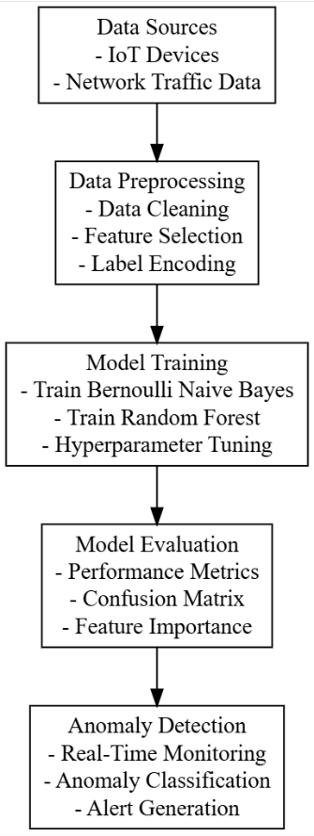
Figure 4.1: Architecture diagram of proposed system
4.2 Data Preprocessing and Splitting
The process begins with the collection and loading of the dataset into the environment, specifically targeting traffic data related to IoT devices under attack by Mirai and BASHLITE botnets. This data is typically rich with various network parameters, including packet size, transmission time, source and destination IPs, etc.
Data Preprocessing:
Null Value Removal:
The dataset undergoes initial preprocessing where null or missing values are identified and removed. Missing data can skew the results or lead to inaccuracies in model predictions. Techniques like removing rows with missing data or imputing values based on statistical measures may be used.
Label Encoding:
After handling null values, categorical variables are converted into numerical formats using label encoding. In this specific context, attack labels (e.g., Normal, BASHLITE, Mirai) are encoded into numerical values to make them interpretable by machine learning models.
Heatmap Visualization:
A correlation heatmap is generated to visualize the relationships between different features in the dataset. This step helps in identifying which features contribute most significantly to the classification task, guiding the selection of important variables for the model.
Data Splitting: 4. Training and Testing Set Creation:
The preprocessed data is split into training and testing sets, usually in a 70-30 ratio. The training set is used to build the model, while the testing set is reserved for evaluating its performance. This step is critical to ensure the model can generalize well to new, unseen data.
4.3 ML Model Building
4.3.1Naive Bayes Classifier
Overview:
- Naive Bayes is a family of probabilistic algorithms based on Bayes' theorem, which assumes independence between the features. It calculates the probability of a data point belonging to a class based on the likelihood of each feature given that class.
Key Characteristics:
- Independence Assumption: Assumes that features are independent, which may not hold true in real-world scenarios.
- Fast and Efficient: Generally computationally efficient, making it suitable for large datasets.
- Good with Small Data: Performs well with small datasets and is particularly effective for text classification (e.g., spam detection).
Performance:
- Often performs well for problems where the independence assumption holds, but its accuracy can drop when features are correlated.
4.3.2 Random Forest Classifier
Overview:
- Random Forest is an ensemble learning method that constructs multiple decision trees during training and outputs the mode of their predictions for classification (or average for regression). It improves accuracy and controls overfitting by aggregating predictions from several trees.
Key Characteristics:
- Ensemble Method: Combines the predictions of multiple trees, which helps reduce overfitting compared to individual decision trees.
- Feature Importance: Can identify the importance of different features in making predictions, aiding in model interpretability.
- Robustness: Handles non-linear relationships and interactions between features effectively.
Performance:
- Generally provides higher accuracy and robustness than Naive Bayes, especially with complex datasets and when features are correlated.
4.3.3 Comparison and When Random Forest Performs Better
- Feature Relationships:
  - Random Forest: Excels when features are correlated or when there are complex interactions. It captures these relationships by constructing multiple trees.
  - Naive Bayes: Struggles in these scenarios due to its independence assumption.
- Data Size:
  - Random Forest: Works well with large datasets and can handle high dimensionality effectively.
  - Naive Bayes: While efficient for smaller datasets, it may not generalize well with complex patterns in larger datasets.
- Model Interpretability:
  - Random Forest: Provides insights into feature importance, making it easier to understand model decisions.
  - Naive Bayes: Less interpretable since it operates purely on probabilities without providing feature importance.
- Handling Outliers:
  - Random Forest: More robust to outliers due to averaging across multiple trees.
  - Naive Bayes: Can be affected by outliers, as it relies on probability distributions.
- Overall Performance:
  - In many practical scenarios, especially those involving complex relationships, high dimensionality, and larger datasets, Random Forest tends to outperform Naive Bayes. It provides better accuracy, robustness, and interpretability, making it a preferred choice in many classification tasks.
4.4 Advantages of the Proposed System
- Enhanced Detection Accuracy:
  - Utilizing ensemble methods like Random Forest improves accuracy in identifying complex attack patterns compared to simpler models, leading to more reliable detection of IoT botnet activities.
- Robustness to Noise and Outliers:
  - The Random Forest classifier's inherent ability to mitigate the impact of noise and outliers results in more stable predictions, enhancing overall system reliability.
- Real-Time Anomaly Detection:
  - The system can be deployed for real-time monitoring of network traffic, enabling immediate detection and response to potential threats, thereby minimizing damage.
- Feature Importance Analysis:
  - The Random Forest model provides insights into feature importance, allowing stakeholders to understand which attributes contribute most significantly to attack detection, aiding in network security strategy formulation.
- Scalability:
  - The proposed system can scale to accommodate larger datasets as IoT environments expand, ensuring consistent performance and adaptability to increasing data volumes.
- Flexibility in Handling Diverse Data Types:
  - The approach can handle a variety of feature types (categorical, numerical) effectively, making it suitable for diverse IoT network configurations.
- Improved Model Generalization:
  - By using ensemble methods, the system reduces the likelihood of overfitting, leading to better generalization on unseen data, which is crucial for effective anomaly detection.
- Efficient Data Processing:
  - The integration of techniques like SMOTE for handling imbalanced datasets ensures that minority classes (e.g., specific attacks) are adequately represented, improving model performance.

CHAPTER 5
UML DIAGRAM
UML stands for Unified Modeling Language. UML is a standardized general-purpose modeling language in the field of object-oriented software engineering. The standard is managed, and was created by, the Object Management Group. The goal is for UML to become a common language for creating models of object-oriented computer software. In its current form UML is comprised of two major components: a Meta-model and a notation. In the future, some form of method or process also be added to; or associated with, UML.
The Unified Modeling Language Is a standard language for specifying, Visualization, Constructing and documenting the artifacts of software system, as well as for business modeling and other non-software systems. The UML represents a collection of best engineering practices that have proven successful in the modeling of large and complex systems. The UML is a very important part of developing objects-oriented software and the software development process. The UML uses mostly graphical notations to express the design of software projects.
GOALS: The Primary goals in the design of the UML are as follows:
- Provide users a ready-to-use, expressive visual modeling Language so that they can develop and exchange meaningful models.
- Provide extendibility and specialization mechanisms to extend the core concepts.
- Be independent of particular programming languages and development process.
- Provide a formal basis for understanding the modeling language.
- Encourage the growth of OO tools market.
- Support higher level development concepts such as collaborations, frameworks, patterns and components.
- Integrate best practices.
Class Diagram
The class diagram is used to refine the use case diagram and define a detailed design of the system. The class diagram classifies the actors defined in the use case diagram into a set of interrelated classes. The relationship or association between the classes can be either an “is-a” or “has-a” relationship. Each class in the class diagram may be capable of providing certain functionalities. These functionalities provided by the class are termed “methods” of the class. Apart from this, each class may have certain “attributes” that uniquely identify the class.
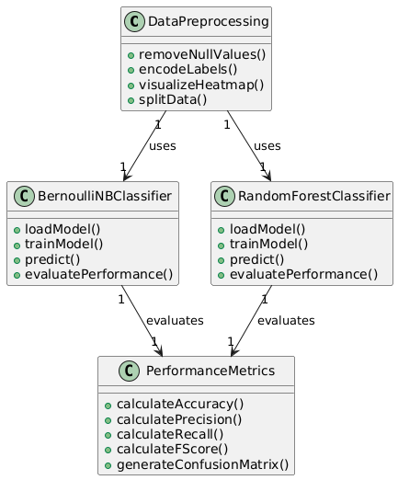
Data flow diagram
A Data Flow Diagram (DFD) is a visual representation of the flow of data within a system or process. It is a structured technique that focuses on how data moves through different processes and data stores within an organization or a system. DFDs are commonly used in system analysis and design to understand, document, and communicate data flow and processing.
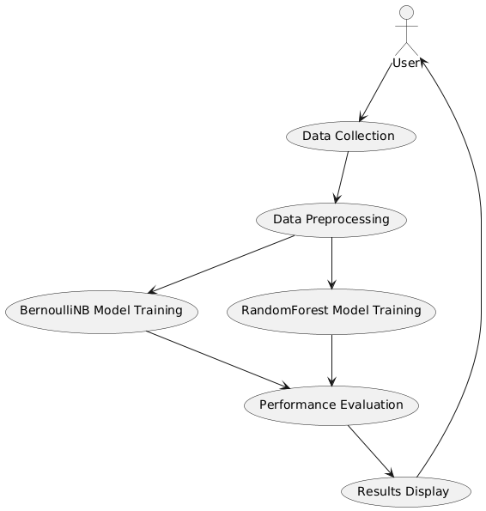
Sequence Diagram
A sequence diagram in Unified Modeling Language (UML) is a kind of interaction diagram that shows how processes operate with one another and in what order. It is a construct of a Message Sequence Chart. A sequence diagram shows, as parallel vertical lines (“lifelines”), different processes or objects that live simultaneously, and as horizontal arrows, the messages exchanged between them, in the order in which they occur. This allows the specification of simple runtime scenarios in a graphical manner.
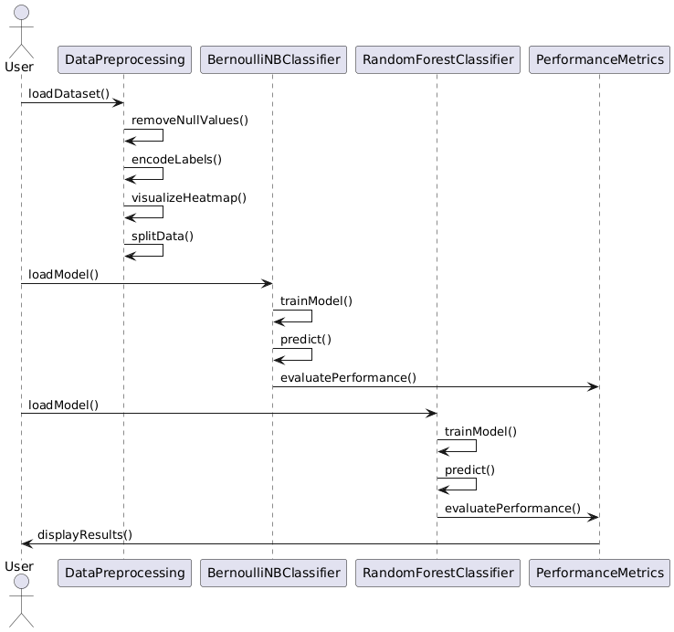
Activity diagram
Activity diagram is another important diagram in UML to describe the dynamic aspects of the system.
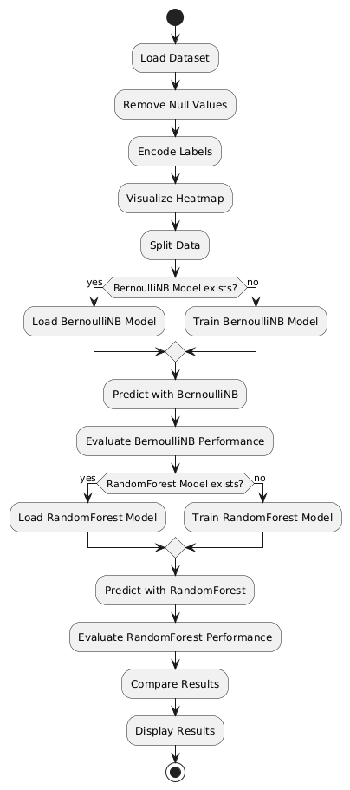

Deployment diagram: The deployment diagram visualizes the physical hardware on which the software will be deployed.
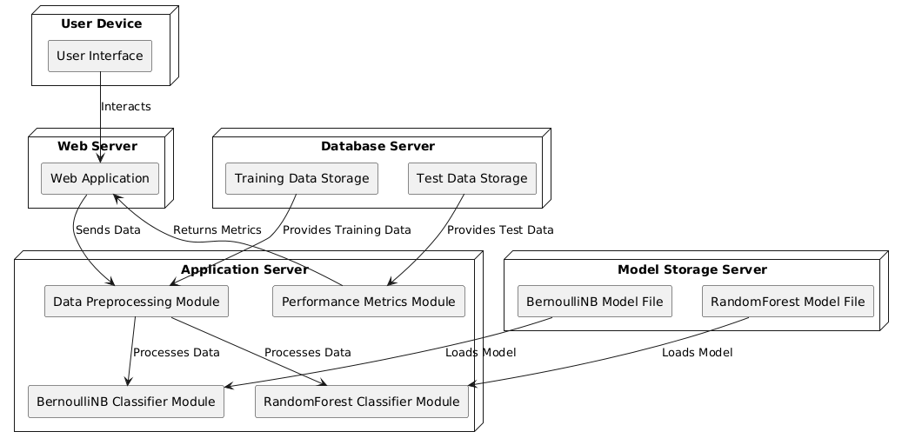
Use case diagram: The purpose of use case diagram is to capture the dynamic aspect of a system.
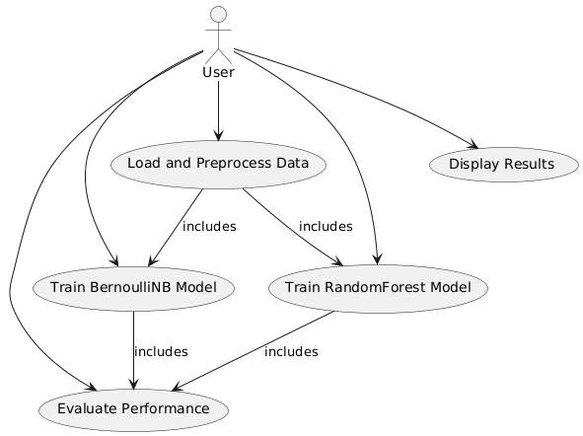
Component diagram: Component diagram describes the organization and wiring of the physical components in a system.
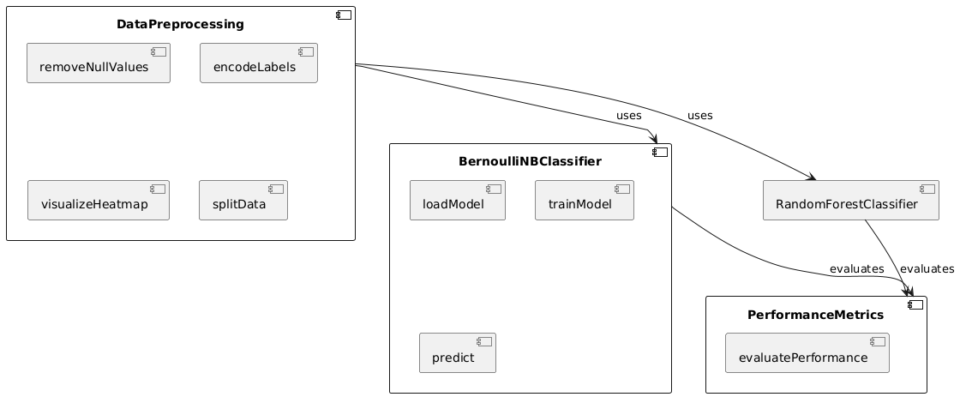

CHAPTER 6
SOFTWARE ENVIRONMENT
What is Python?
Below are some facts about Python.
- Python is currently the most widely used multi-purpose, high-level programming language.
- Python allows programming in Object-Oriented and Procedural paradigms. Python programs generally are smaller than other programming languages like Java.
- Programmers have to type relatively less and indentation requirement of the language, makes them readable all the time.
- Python language is being used by almost all tech-giant companies like – Google, Amazon, Facebook, Instagram, Dropbox, Uber… etc.
The biggest strength of Python is huge collection of standard libraries which can be used for the following –
  - Machine Learning
  - GUI Applications (like Kivy, Tkinter, PyQt etc.)
  - Web frameworks like Django (used by YouTube, Instagram, Dropbox)
  - Image processing (like Opencv, Pillow)
  - Web scraping (like Scrapy, BeautifulSoup, Selenium)
  - Test frameworks
  - Multimedia
Advantages of Python
Let’s see how Python dominates over other languages.
- Extensive Libraries
Python downloads with an extensive library and it contain code for various purposes like regular expressions, documentation-generation, unit-testing, web browsers, threading, databases, CGI, email, image manipulation, and more. So, we don’t have to write the complete code for that manually.
- Extensible
As we have seen earlier, Python can be extended to other languages. You can write some of your code in languages like C++ or C. This comes in handy, especially in projects.
- Embeddable
Complimentary to extensibility, Python is embeddable as well. You can put your Python code in your source code of a different language, like C++. This lets us add scripting capabilities to our code in the other language.
- Improved Productivity
The language’s simplicity and extensive libraries render programmers more productive than languages like Java and C++ do. Also, the fact that you need to write less and get more things done.
- IOT Opportunities
Since Python forms the basis of new platforms like Raspberry Pi, it finds the future bright for the Internet of Things. This is a way to connect the language with the real world.
- Simple and Easy
When working with Java, you may have to create a class to print ‘Hello World’. But in Python, just a print statement will do. It is also quite easy to learn, understand, and code. This is why when people pick up Python, they have a hard time adjusting to other more verbose languages like Java.
- Readable
Because it is not such a verbose language, reading Python is much like reading English. This is the reason why it is so easy to learn, understand, and code. It also does not need curly braces to define blocks, and indentation is mandatory. These further aids the readability of the code.
- Object-Oriented
This language supports both the procedural and object-oriented programming paradigms. While functions help us with code reusability, classes and objects let us model the real world. A class allows the encapsulation of data and functions into one.
- Free and Open-Source
Like we said earlier, Python is freely available. But not only can you download Python for free, but you can also download its source code, make changes to it, and even distribute it. It downloads with an extensive collection of libraries to help you with your tasks.
- Portable
When you code your project in a language like C++, you may need to make some changes to it if you want to run it on another platform. But it isn’t the same with Python. Here, you need to code only once, and you can run it anywhere. This is called Write Once Run Anywhere (WORA). However, you need to be careful enough not to include any system-dependent features.
- Interpreted
Lastly, we will say that it is an interpreted language. Since statements are executed one by one, debugging is easier than in compiled languages.
Any doubts till now in the advantages of Python? Mention in the comment section.
Advantages of Python Over Other Languages
- Less Coding
Almost all of the tasks done in Python requires less coding when the same task is done in other languages. Python also has an awesome standard library support, so you don’t have to search for any third-party libraries to get your job done. This is the reason that many people suggest learning Python to beginners.
- Affordable
Python is free therefore individuals, small companies or big organizations can leverage the free available resources to build applications. Python is popular and widely used so it gives you better community support.
The 2019 Github annual survey showed us that Python has overtaken Java in the most popular programming language category.
- Python is for Everyone
Python code can run on any machine whether it is Linux, Mac or Windows. Programmers need to learn different languages for different jobs but with Python, you can professionally build web apps, perform data analysis and machine learning, automate things, do web scraping and also build games and powerful visualizations. It is an all-rounder programming language.
Disadvantages of Python
So far, we’ve seen why Python is a great choice for your project. But if you choose it, you should be aware of its consequences as well. Let’s now see the downsides of choosing Python over another language.
1. Speed Limitations
We have seen that Python code is executed line by line. But since Python is interpreted, it often results in slow execution. This, however, isn’t a problem unless speed is a focal point for the project. In other words, unless high speed is a requirement, the benefits offered by Python are enough to distract us from its speed limitations.
2. Weak in Mobile Computing and Browsers
While it serves as an excellent server-side language, Python is much rarely seen on the client-side. Besides that, it is rarely ever used to implement smartphone-based applications. One such application is called Carbonnelle.
The reason it is not so famous despite the existence of Brython is that it isn’t that secure.
3. Design Restrictions
As you know, Python is dynamically-typed. This means that you don’t need to declare the type of variable while writing the code. It uses duck-typing. But wait, what’s that? Well, it just means that if it looks like a duck, it must be a duck. While this is easy on the programmers during coding, it can raise run-time errors.
4. Underdeveloped Database Access Layers
Compared to more widely used technologies like JDBC (Java DataBase Connectivity) and ODBC (Open DataBase Connectivity), Python’s database access layers are a bit underdeveloped. Consequently, it is less often applied in huge enterprises.
5. Simple
No, we’re not kidding. Python’s simplicity can indeed be a problem. Take my example. I don’t do Java, I’m more of a Python person. To me, its syntax is so simple that the verbosity of Java code seems unnecessary.
This was all about the Advantages and Disadvantages of Python Programming Language.
History of Python
What do the alphabet and the programming language Python have in common? Right, both start with ABC. If we are talking about ABC in the Python context, it's clear that the programming language ABC is meant. ABC is a general-purpose programming language and programming environment, which had been developed in the Netherlands, Amsterdam, at the CWI (Centrum Wiskunde &Informatica). The greatest achievement of ABC was to influence the design of Python. Python was conceptualized in the late 1980s. Guido van Rossum worked that time in a project at the CWI, called Amoeba, a distributed operating system. In an interview with Bill Venners¹, Guido van Rossum said: "In the early 1980s, I worked as an implementer on a team building a language called ABC at Centrum voor Wiskunde en Informatica (CWI). I don't know how well people know ABC's influence on Python. I try to mention ABC's influence because I'm indebted to everything I learned during that project and to the people who worked on it. "Later on in the same Interview, Guido van Rossum continued: "I remembered all my experience and some of my frustration with ABC. I decided to try to design a simple scripting language that possessed some of ABC's better properties, but without its problems. So, I started typing. I created a simple virtual machine, a simple parser, and a simple runtime. I made my own version of the various ABC parts that I liked. I created a basic syntax, used indentation for statement grouping instead of curly braces or begin-end blocks, and developed a small number of powerful data types: a hash table (or dictionary, as we call it), a list, strings, and numbers."
Python Development Steps
Guido Van Rossum published the first version of Python code (version 0.9.0) at alt.sources in February 1991. This release included already exception handling, functions, and the core data types of lists, dict, str and others. It was also object oriented and had a module system.
Python version 1.0 was released in January 1994. The major new features included in this release were the functional programming tools lambda, map, filter and reduce, which Guido Van Rossum never liked. Six and a half years later in October 2000, Python 2.0 was introduced. This release included list comprehensions, a full garbage collector and it was supporting unicode. Python flourished for another 8 years in the versions 2.x before the next major release as Python 3.0 (also known as "Python 3000" and "Py3K") was released. Python 3 is not backwards compatible with Python 2.x. The emphasis in Python 3 had been on the removal of duplicate programming constructs and modules, thus fulfilling or coming close to fulfilling the 13th law of the Zen of Python: "There should be one -- and preferably only one -- obvious way to do it."Some changes in Python 7.3:
- Print is now a function.
- Views and iterators instead of lists
- The rules for ordering comparisons have been simplified. E.g., a heterogeneous list cannot be sorted, because all the elements of a list must be comparable to each other.
- There is only one integer type left, i.e., int. long is int as well.
- The division of two integers returns a float instead of an integer. "//" can be used to have the "old" behaviour.
- Text Vs. Data Instead of Unicode Vs. 8-bit
Purpose
We demonstrated that our approach enables successful segmentation of intra-retinal layers—even with low-quality images containing speckle noise, low contrast, and different intensity ranges throughout—with the assistance of the ANIS feature.
Python
Python is an interpreted high-level programming language for general-purpose programming. Created by Guido van Rossum and first released in 1991, Python has a design philosophy that emphasizes code readability, notably using significant whitespace.
Python features a dynamic type system and automatic memory management. It supports multiple programming paradigms, including object-oriented, imperative, functional and procedural, and has a large and comprehensive standard library.
- Python is Interpreted − Python is processed at runtime by the interpreter. You do not need to compile your program before executing it. This is similar to PERL and PHP.
- Python is Interactive − you can actually sit at a Python prompt and interact with the interpreter directly to write your programs.
Python also acknowledges that speed of development is important. Readable and terse code is part of this, and so is access to powerful constructs that avoid tedious repetition of code. Maintainability also ties into this may be an all but useless metric, but it does say something about how much code you have to scan, read and/or understand to troubleshoot problems or tweak behaviors. This speed of development, the ease with which a programmer of other languages can pick up basic Python skills and the huge standard library is key to another area where Python excels. All its tools have been quick to implement, saved a lot of time, and several of them have later been patched and updated by people with no Python background - without breaking.
Modules Used in Project
TensorFlow
TensorFlow is a free and open-source software library for dataflow and differentiable programming across a range of tasks. It is a symbolic math library and is also used for machine learning applications such as neural networks. It is used for both research and production at Google.‍
TensorFlow was developed by the Google Brain team for internal Google use. It was released under the Apache 2.0 open-source license on November 9, 2015.
NumPy
NumPy is a general-purpose array-processing package. It provides a high-performance multidimensional array object, and tools for working with these arrays.
It is the fundamental package for scientific computing with Python. It contains various features including these important ones:
- A powerful N-dimensional array object
- Sophisticated (broadcasting) functions
- Tools for integrating C/C++ and Fortran code
- Useful linear algebra, Fourier transform, and random number capabilities
Besides its obvious scientific uses, NumPy can also be used as an efficient multi-dimensional container of generic data. Arbitrary datatypes can be defined using NumPy which allows NumPy to seamlessly and speedily integrate with a wide variety of databases.
Pandas
Pandas is an open-source Python Library providing high-performance data manipulation and analysis tool using its powerful data structures. Python was majorly used for data munging and preparation. It had very little contribution towards data analysis. Pandas solved this problem. Using Pandas, we can accomplish five typical steps in the processing and analysis of data, regardless of the origin of data load, prepare, manipulate, model, and analyze. Python with Pandas is used in a wide range of fields including academic and commercial domains including finance, economics, Statistics, analytics, etc.
Matplotlib
Matplotlib is a Python 2D plotting library which produces publication quality figures in a variety of hardcopy formats and interactive environments across platforms. Matplotlib can be used in Python scripts, the Python and IPython shells, the Jupyter Notebook, web application servers, and four graphical user interface toolkits. Matplotlib tries to make easy things easy and hard things possible. You can generate plots, histograms, power spectra, bar charts, error charts, scatter plots, etc., with just a few lines of code. For examples, see the sample plots and thumbnail gallery.
For simple plotting the pyplot module provides a MATLAB-like interface, particularly when combined with IPython. For the power user, you have full control of line styles, font properties, axes properties, etc, via an object-oriented interface or via a set of functions familiar to MATLAB users.
Scikit – learn
Scikit-learn provides a range of supervised and unsupervised learning algorithms via a consistent interface in Python. It is licensed under a permissive simplified BSD license and is distributed under many Linux distributions, encouraging academic and commercial use. Python
Python is an interpreted high-level programming language for general-purpose programming. Created by Guido van Rossum and first released in 1991, Python has a design philosophy that emphasizes code readability, notably using significant whitespace.
Python features a dynamic type system and automatic memory management. It supports multiple programming paradigms, including object-oriented, imperative, functional and procedural, and has a large and comprehensive standard library.
- Python is Interpreted − Python is processed at runtime by the interpreter. You do not need to compile your program before executing it. This is similar to PERL and PHP.
- Python is Interactive − you can actually sit at a Python prompt and interact with the interpreter directly to write your programs.
Python also acknowledges that speed of development is important. Readable and terse code is part of this, and so is access to powerful constructs that avoid tedious repetition of code. Maintainability also ties into this may be an all but useless metric, but it does say something about how much code you have to scan, read and/or understand to troubleshoot problems or tweak behaviors. This speed of development, the ease with which a programmer of other languages can pick up basic Python skills and the huge standard library is key to another area where Python excels. All its tools have been quick to implement, saved a lot of time, and several of them have later been patched and updated by people with no Python background - without breaking.
Install Python Step-by-Step in Windows and Mac
Python a versatile programming language doesn’t come pre-installed on your computer devices. Python was first released in the year 1991 and until today it is a very popular high-level programming language. Its style philosophy emphasizes code readability with its notable use of great whitespace.
The object-oriented approach and language construct provided by Python enables programmers to write both clear and logical code for projects. This software does not come pre-packaged with Windows.
How to Install Python on Windows and Mac
There have been several updates in the Python version over the years. The question is how to install Python? It might be confusing for the beginner who is willing to start learning Python but this tutorial will solve your query. The latest or the newest version of Python is version 3.7.4 or in other words, it is Python 3.
Note: The python version 3.7.4 cannot be used on Windows XP or earlier devices.
Before you start with the installation process of Python. First, you need to know about your System Requirements. Based on your system type i.e., operating system and based processor, you must download the python version. My system type is a Windows 64-bit operating system. So, the steps below are to install python version 3.7.4 on Windows 7 device or to install Python 3. Download the Python Cheatsheet here. The steps on how to install Python on Windows 10, 8 and 7 are divided into 4 parts to help understand better.
Download the Correct version into the system
Step 1: Go to the official site to download and install python using Google Chrome or any other web browser. OR Click on the following link: https://www.python.org
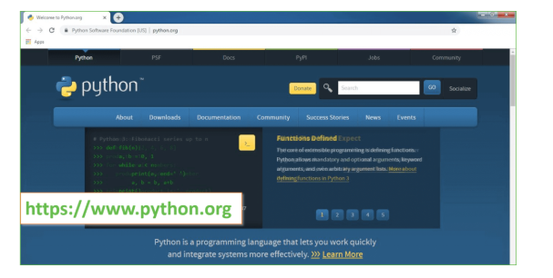
Now, check for the latest and the correct version for your operating system.
Step 2: Click on the Download Tab.
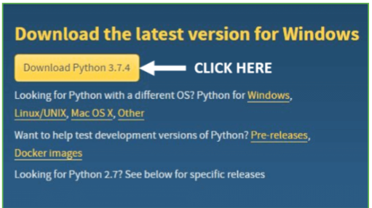
Step 3: You can either select the Download Python for windows 3.7.4 button in Yellow Color or you can scroll further down and click on download with respective to their version. Here, we are downloading the most recent python version for windows 3.7.4
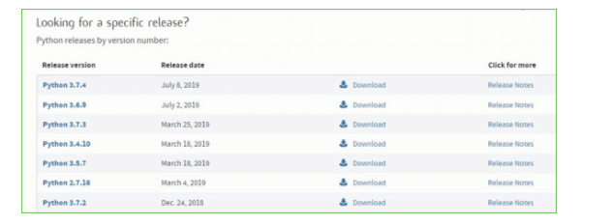
Step 4: Scroll down the page until you find the Files option.
Step 5: Here you see a different version of python along with the operating system.
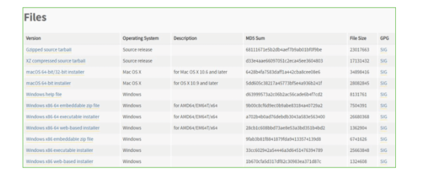
- To download Windows 32-bit python, you can select any one from the three options: Windows x86 embeddable zip file, Windows x86 executable installer or Windows x86 web-based installer.
- To download Windows 64-bit python, you can select any one from the three options: Windows x86-64 embeddable zip file, Windows x86-64 executable installer or Windows x86-64 web-based installer.
Here we will install Windows x86-64 web-based installer. Here your first part regarding which version of python is to be downloaded is completed. Now we move ahead with the second part in installing python i.e., Installation
Note: To know the changes or updates that are made in the version you can click on the Release Note Option.
Installation of Python
Step 1: Go to Download and Open the downloaded python version to carry out the installation process.
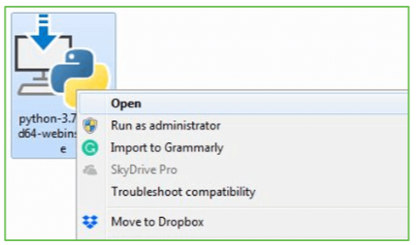
Step 2: Before you click on Install Now, make sure to put a tick on Add Python 3.7 to PATH.
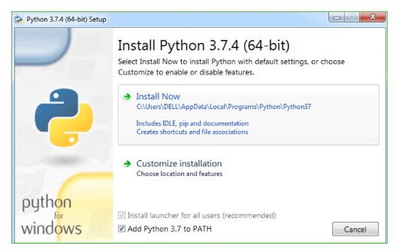
Step 3: Click on Install NOW After the installation is successful. Click on Close.
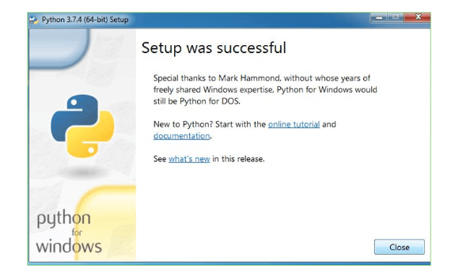
With these above three steps on python installation, you have successfully and correctly installed Python. Now is the time to verify the installation.
Note: The installation process might take a couple of minutes.
Verify the Python Installation
Step 1: Click on Start
Step 2: In the Windows Run Command, type “cmd”.
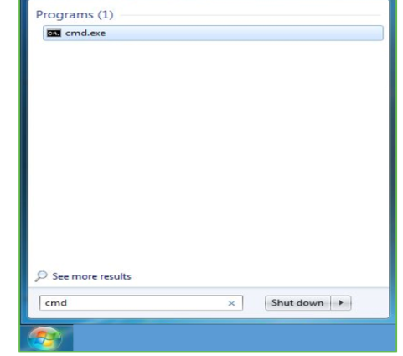
Step 3: Open the Command prompt option.
Step 4: Let us test whether the python is correctly installed. Type python –V and press Enter.
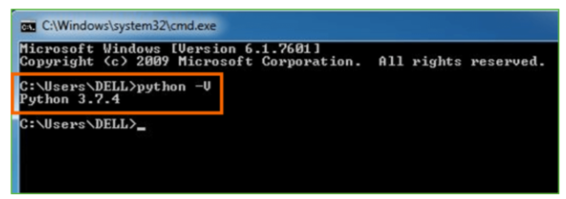
Step 5: You will get the answer as 3.7.4
Note: If you have any of the earlier versions of Python already installed. You must first uninstall the earlier version and then install the new one.
Check how the Python IDLE works
Step 1: Click on Start
Step 2: In the Windows Run command, type “python idle”.
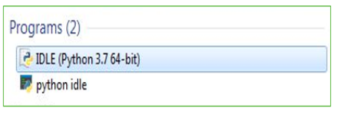
Step 3: Click on IDLE (Python 3.7 64-bit) and launch the program
Step 4: To go ahead with working in IDLE you must first save the file. Click on File > Click on Save
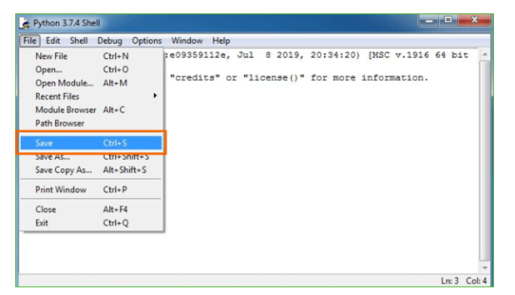
Step 5: Name the file and save as type should be Python files. Click on SAVE. Here I have named the files as Hey World.
Step 6: Now for e.g., enter print (“Hey World”) and Press Enter.
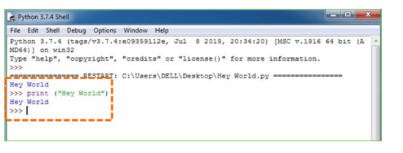
You will see that the command given is launched. With this, we end our tutorial on how to install Python. You have learned how to download python for windows into your respective operating system.
Note: Unlike Java, Python does not need semicolons at the end of the statements otherwise it won’t work.

CHAPTER 7
SYSTEM REQUIREMENTS SPECIFICATIONS
Software Requirements
The functional requirements or the overall description documents include the product perspective and features, operating system and operating environment, graphics requirements, design constraints and user documentation.
The appropriation of requirements and implementation constraints gives the general overview of the project in regard to what the areas of strength and deficit are and how to tackle them.
- Python IDLE 3.7 version (or)
- Anaconda 3.7 (or)
- Jupiter (or)
- Google colab
Hardware Requirements
Minimum hardware requirements are very dependent on the particular software being developed by a given Enthought Python / Canopy / VS Code user. Applications that need to store large arrays/objects in memory will require more RAM, whereas applications that need to perform numerous calculations or tasks more quickly will require a faster processor.
Operating system : Windows, Linux
Processor : minimum intel i3
Ram : minimum 4 GB
Hard disk : minimum 250GB

CHAPTER 8
FUNCTIONAL REQUIREMENTS
Output Design
Outputs from computer systems are required primarily to communicate the results of processing to users. They are also used to provides a permanent copy of the results for later consultation. The various types of outputs in general are:
- External Outputs, whose destination is outside the organization
- Internal Outputs whose destination is within organization and they are the
- User’s main interface with the computer.
- Operational outputs whose use is purely within the computer department.
- Interface outputs, which involve the user in communicating directly.
Output Definition
The outputs should be defined in terms of the following points:
- Type of the output
- Content of the output
- Format of the output
- Location of the output
- Frequency of the output
- Volume of the output
- Sequence of the output
It is not always desirable to print or display data as it is held on a computer. It should be decided as which form of the output is the most suitable.
Input Design
Input design is a part of overall system design. The main objective during the input design is as given below:
- To produce a cost-effective method of input.
- To achieve the highest possible level of accuracy.
- To ensure that the input is acceptable and understood by the user.
Input Stages
The main input stages can be listed as below:
- Data recording
- Data transcription
- Data conversion
- Data verification
- Data control
- Data transmission
- Data validation
- Data correction
Input Types
It is necessary to determine the various types of inputs. Inputs can be categorized as follows:
- External inputs, which are prime inputs for the system.
- Internal inputs, which are user communications with the system.
- Operational, which are computer department’s communications to the system?
- Interactive, which are inputs entered during a dialogue.
Input Media
At this stage choice has to be made about the input media. To conclude about the input media consideration has to be given to;
- Type of input
- Flexibility of format
- Speed
- Accuracy
- Verification methods
- Rejection rates
- Ease of correction
- Storage and handling requirements
- Security
- Easy to use
- Portability
Keeping in view the above description of the input types and input media, it can be said that most of the inputs are of the form of internal and interactive. As
Input data is to be the directly keyed in by the user, the keyboard can be considered to be the most suitable input device.
Error Avoidance
At this stage care is to be taken to ensure that input data remains accurate form the stage at which it is recorded up to the stage in which the data is accepted by the system. This can be achieved only by means of careful control each time the data is handled.
Error Detection
Even though every effort is made to avoid the occurrence of errors, still a small proportion of errors is always likely to occur, these types of errors can be discovered by using validations to check the input data.
Data Validation
Procedures are designed to detect errors in data at a lower level of detail. Data validations have been included in the system in almost every area where there is a possibility for the user to commit errors. The system will not accept invalid data. Whenever an invalid data is keyed in, the system immediately prompts the user and the user has to again key in the data and the system will accept the data only if the data is correct. Validations have been included where necessary.
The system is designed to be a user friendly one. In other words the system has been designed to communicate effectively with the user. The system has been designed with popup menus.
User Interface Design
It is essential to consult the system users and discuss their needs while designing the user interface:
User Interface Systems Can Be Broadly Clasified As:
- User initiated interface the user is in charge, controlling the progress of the user/computer dialogue. In the computer-initiated interface, the computer selects the next stage in the interaction.
- Computer initiated interfaces
In the computer-initiated interfaces the computer guides the progress of the user/computer dialogue. Information is displayed and the user response of the computer takes action or displays further information.
User Initiated Intergfaces
User initiated interfaces fall into two approximate classes:
- Command driven interfaces: In this type of interface the user inputs commands or queries which are interpreted by the computer.
- Forms oriented interface: The user calls up an image of the form to his/her screen and fills in the form. The forms-oriented interface is chosen because it is the best choice.
Computer-Initiated Interfaces
The following computer – initiated interfaces were used:
- The menu system for the user is presented with a list of alternatives and the user chooses one; of alternatives.
- Questions – answer type dialog system where the computer asks question and takes action based on the basis of the users reply.
Right from the start the system is going to be menu driven, the opening menu displays the available options. Choosing one option gives another popup menu with more options. In this way every option leads the users to data entry form where the user can key in the data.
Error Message Design
The design of error messages is an important part of the user interface design. As user is bound to commit some errors or other while designing a system the system should be designed to be helpful by providing the user with information regarding the error he/she has committed.
This application must be able to produce output at different modules for different inputs.
Performance Requirements
Performance is measured in terms of the output provided by the application. Requirement specification plays an important part in the analysis of a system. Only when the requirement specifications are properly given, it is possible to design a system, which will fit into required environment. It rests largely in the part of the users of the existing system to give the requirement specifications because they are the people who finally use the system. This is because the requirements have to be known during the initial stages so that the system can be designed according to those requirements. It is very difficult to change the system once it has been designed and on the other hand designing a system, which does not cater to the requirements of the user, is of no use.
The requirement specification for any system can be broadly stated as given below:
- The system should be able to interface with the existing system
- The system should be accurate
- The system should be better than the existing system
- The existing system is completely dependent on the user to perform all the duties.

CHAPTER 9
SOURCE CODE
# AI Framework for Identifying Anomalous Network Traffic in Mirai and BASHLITE IoT Botnet Attacks
## Importing Libraries
import numpy as np
import pandas as pd
import matplotlib.pyplot as plt
import seaborn as sns
import warnings
warnings.filterwarnings('ignore')
from sklearn.preprocessing import LabelEncoder
from imblearn.over_sampling import SMOTE
from sklearn.model_selection import train_test_split
from sklearn.metrics import precision_score
from sklearn.metrics import recall_score
from sklearn.metrics import f1_score
from sklearn.metrics import accuracy_score,confusion_matrix,classification_report
import os
import joblib
from sklearn.naive_bayes import BernoulliNB
from sklearn.ensemble import RandomForestClassifier
## Data Analysis
data = pd.read_csv(r"C:\Users\USER\Desktop\saint martins\Traffic\BoTNeTIoT-L01-v2.csv")
data
data.head()
data.tail()
data.describe()
data.info()
data['Attack'].unique() #it refers to a value that appears only once or a distinct value within a specific dataset or column of a dataset
## Data preprocessing
data.isnull().sum()
data.shape
### Heatmap
labels = set(data['Attack'])
labels
plt.figure(figsize=(15,10))
sns.heatmap(data.corr(),cmap = 'Accent',annot = True)
plt.xticks(rotation = 80)
plt.yticks(rotation = 45)
plt.show()
labels = ['Normal', 'BASHLITE', 'Mirai']
labels
columns = ['Device_Name','Attack_subType']
data = data.drop(columns = columns)
data
Labels = ['Attack']

for i in Labels:
data[i] = LabelEncoder().fit_transform(data[i])
data
### countplot
sns.set(style="darkgrid")
plt.figure(figsize=(12, 6))
ax = sns.countplot(x=data['Attack'], palette="Set2")
plt.title("Count Plot")
plt.xlabel("Categories")
plt.ylabel("Count")
plt.show()
x = data.drop(['Attack'], axis = 1)
x
y = data['Attack']
y
## Splitting the Data
x_train, x_test, y_train, y_test = train_test_split(x,y, test_size = 0.30, random_state = 42)
x_train
y_train
x_test
y_test
x_train.shape
y_train.shape
## Performance Evaluation
precision = []
recall = []
fscore = []
accuracy = []

def performance_metrics(algorithm, predict, testY):
testY = testY.astype('int')
predict = predict.astype('int')
p = precision_score(testY, predict,average='macro') * 100
r = recall_score(testY, predict,average='macro') * 100
f = f1_score(testY, predict,average='macro') * 100
a = accuracy_score(testY,predict)*100
accuracy.append(a)
precision.append(p)
recall.append(r)
fscore.append(f)
print(algorithm+' Accuracy : '+str(a))
print(algorithm+' Precision : '+str(p))
print(algorithm+' Recall : '+str(r))
print(algorithm+' FSCORE : '+str(f))
report=classification_report(predict, testY,target_names=labels)
print('\n',algorithm+" classification report\n",report)
conf_matrix = confusion_matrix(testY, predict)
plt.figure(figsize =(5, 5))
ax = sns.heatmap(conf_matrix, xticklabels = labels, yticklabels = labels, annot = True, cmap="Blues" ,fmt ="g");
ax.set_ylim([0,len(labels)])
plt.title(algorithm+" Confusion matrix")
plt.ylabel('True class')
plt.xlabel('Predicted class')
plt.show()
## BernoulliNBClassifier Algorithm
if os.path.exists('BernoulliNBClassifier.pkl'):
# Load the Bernoulli Naive Bayes Classifier model
bnb_classifier = joblib.load('BernoulliNBClassifier.pkl')
predict = bnb_classifier.predict(x_test)
else:
# Train and save the Bernoulli Naive Bayes Classifier model
bnb_classifier = BernoulliNB()
bnb_classifier.fit(x_train, y_train)
joblib.dump(bnb_classifier, 'BernoulliNBClassifier.pkl')

# Predict using the trained Bernoulli Naive Bayes Classifier model
y_pred_bnb = bnb_classifier.predict(x_test)

# Evaluate the Bernoulli Naive Bayes Classifier model
performance_metrics('BernoulliNBClassifier', y_pred_bnb, y_test)
## RandomForestClassifier
if os.path.exists('RandomForest_weights.pkl'):
# Load the model from the pkl file
classifier = joblib.load('RandomForest_weights.pkl')
else:
# Train the classifier on the training data
classifier = RandomForestClassifier(random_state=42)
classifier.fit(x_train, y_train)
# Save the model weights to a pkl file
joblib.dump(classifier, 'RandomForest_weights.pkl')
print("RandomForest classifier model trained and model weights saved.")

y_pred = classifier.predict(x_test)
performance_metrics("RandomForest Classifier", y_pred, y_test)
test = pd.read_csv(r"test.csv")
test
test.info()
columns = ['Device_Name','Attack_subType']
test = test.drop(columns = columns)
test
predict = classifier.predict(test)
predict
A='Normal'
B='BASHLITE'
c='mirai'
#test = pd.read_csv((r"test.csv")
predict = classifier.predict(test)
for i in range(len(predict)):
if predict[i] == 0:
print("{} :{} ".format(test.iloc[i,:],A))
elif predict[i] == 1:
print("{} {} ".format(test.iloc[i,:],B))
elif predict[i]== 2:
print("{} :{} ".format(test.iloc[i, :],c))

CHAPTER 10
RESULTS AND DISCUSSION

10.1 Implementation Description
1. Data Collection and Preprocessing: The project begins by acquiring network traffic data, which includes a range of features capturing different aspects of network behavior. The data is then preprocessed to prepare it for analysis. This involves handling missing values, dropping irrelevant columns, and encoding categorical variables using label encoding to convert them into a numerical format. Additionally, a heatmap is generated to understand the correlation between features, which helps in feature selection and dimensionality reduction.
2. Exploratory Data Analysis (EDA): EDA is performed to gain insights into the data distribution and the prevalence of different attack types, such as 'Normal,' 'BASHLITE,' and 'Mirai.' Visualization techniques like count plots are used to visualize the frequency of attack labels in the dataset. This step helps in understanding the dataset's structure and identifying any imbalances in the data, which is critical for model training.
3. Data Splitting: The preprocessed data is split into training and testing sets using an 80-20 split. The training set is used to train the machine learning models, while the testing set is reserved for evaluating the model's performance. A stratified sampling approach is applied to ensure that the distribution of attack types in both the training and testing sets remains consistent with the overall dataset.
4. Model Training: Two machine learning algorithms, Bernoulli Naive Bayes and Random Forest, are implemented for anomaly detection in the IoT network traffic. Each model is trained using the training data:
Bernoulli Naive Bayes: This algorithm is selected due to its simplicity and efficiency in handling binary or categorical data. It is particularly well-suited for high-dimensional datasets and provides a baseline model for comparison.
Random Forest Classifier: A more complex ensemble learning method, Random Forest, is employed to enhance detection accuracy. This model leverages multiple decision trees to improve generalization and robustness, making it suitable for identifying complex attack patterns.
5. Model Evaluation: After training, the models are evaluated using the testing set. Several performance metrics are calculated, including accuracy, precision, recall, and F1-score. These metrics provide a comprehensive understanding of the model's ability to correctly identify normal and anomalous traffic. Additionally, confusion matrices are generated to visualize the classification performance, highlighting the true positives, false positives, true negatives, and false negatives for each attack type.
6. Performance Comparison: The performance of both the Bernoulli Naive Bayes and Random Forest models is compared. While the Bernoulli Naive Bayes model provides a quick and efficient baseline, the Random Forest model typically offers higher accuracy and better generalization. The comparison helps in determining the most effective model for deployment in real-world scenarios.
7. Anomaly Detection in New Data: Once the models are trained and evaluated, they are used to predict anomalies in new, unseen data. The trained Random Forest model is particularly employed to classify new network traffic data into 'Normal,' 'BASHLITE,' and 'Mirai' categories. The prediction results are then analyzed to understand the model's ability to detect and classify network attacks in real-time.
8. Results Interpretation: The predictions are further analyzed by mapping the numerical predictions back to their respective categories ('Normal,' 'BASHLITE,' 'Mirai'). This step involves interpreting the model's output and understanding the classification of each network flow in the test dataset. The results help in validating the effectiveness of the AI framework in accurately identifying anomalous traffic.
9. Model Deployment and Future Enhancements: Finally, the trained models are saved for deployment in a real-time network monitoring system. The deployment phase involves integrating the models into a network security infrastructure where they can continuously analyze incoming traffic and detect potential botnet attacks. Future enhancements may include fine-tuning the models, incorporating additional features, or leveraging more advanced techniques such as deep learning for improved detection accuracy.

10.2 Dataset Description
The dataset utilized in this project is crucial for training and evaluating the AI framework designed to detect anomalous network traffic associated with Mirai and BASHLITE IoT botnet attacks. The dataset, sourced from real-world IoT network traffic, contains a comprehensive collection of features that describe both normal and malicious activities, enabling the development of accurate and reliable machine learning models.
10.2.1 Data Source
The dataset, named "BoTNeTIoT-L01-v2.csv," was obtained from a publicly available repository that focuses on IoT security. This dataset is specifically tailored to reflect the network behaviors of IoT devices under both normal conditions and during botnet attacks, providing a rich and diverse set of data points for analysis.
10.2.2 Features and Attributes
The dataset contains numerous features that capture various aspects of network traffic, such as packet sizes, communication protocols, and time-based metrics. Some of the key features include:
Src IP (Source IP): The IP address from which the network traffic originates.
Dst IP (Destination IP): The IP address to which the network traffic is directed.
Src Port (Source Port): The port number from which the traffic is sent.
Dst Port (Destination Port): The port number to which the traffic is destined.
Protocol: The communication protocol used (e.g., TCP, UDP).
Flow Duration: The duration of the network flow in microseconds.
Total Fwd Packets: The total number of packets sent in the forward direction.
Total Backward Packets: The total number of packets sent in the backward direction.
Attack: The target variable indicating whether the traffic is associated with an attack. This feature has been encoded into numeric labels for machine learning purposes: 0 for Normal traffic, 1 for BASHLITE, and 2 for Mirai.
10.2.3 Data Preprocessing
Before feeding the data into the machine learning models, several preprocessing steps were performed:
Handling Missing Values: The dataset was checked for any missing values, and necessary imputation or removal was carried out to ensure data integrity.
Feature Selection: Redundant or irrelevant features, such as Device_Name and Attack_subType, were dropped from the dataset to focus on the most impactful attributes.
Label Encoding: The categorical target variable Attack was converted into numeric labels using LabelEncoder to facilitate model training.
Data Normalization: Continuous features were normalized to ensure that the models could learn effectively without being biased by the scale of the data.
Class Imbalance Handling: Given the potential imbalance between normal and attack classes, techniques like SMOTE (Synthetic Minority Over-sampling Technique) were applied to ensure that the models could accurately learn from all categories.
10.2.4 Data Splitting
The dataset was divided into training and testing subsets to evaluate the performance of the machine learning models. Typically, 70% of the data was used for training, while the remaining 30% was reserved for testing. This split ensured that the models were trained on a sufficient amount of data while still being evaluated on unseen samples to assess their generalization capability.
10.2.5 Data Visualization
To gain initial insights into the data, visualizations such as heatmaps and count plots were generated. The heatmap illustrated the correlation between different features, helping identify the most influential attributes for detecting anomalous traffic. The count plot provided a visual distribution of the different attack types in the dataset, highlighting any class imbalances that needed to be addressed during model training.
10.2.6 Dataset Usage
The dataset was employed to train and evaluate two machine learning algorithms: Bernoulli Naive Bayes (BNB) and Random Forest Classifier (RFC). These models were trained to distinguish between normal traffic and traffic indicative of Mirai and BASHLITE botnet attacks. The processed dataset enabled the development of an AI framework that effectively identifies anomalous traffic patterns, contributing to enhanced network security in IoT environments.

10.3 Results Description
The results of the analysis and machine learning models applied to the dataset are detailed below. Figures and tables included in this section visually represent key aspects of the dataset, model performance, and predictions.
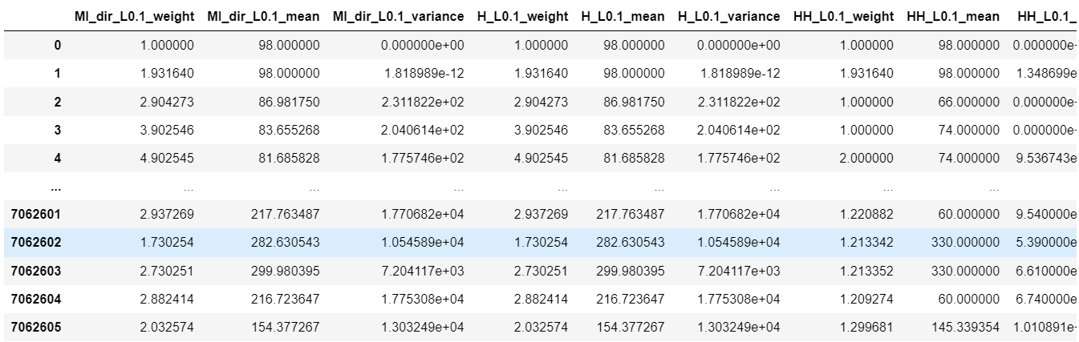Figure 10.1: Overview of the Dataset
This figure displays the first few rows and last few rows of the dataset.
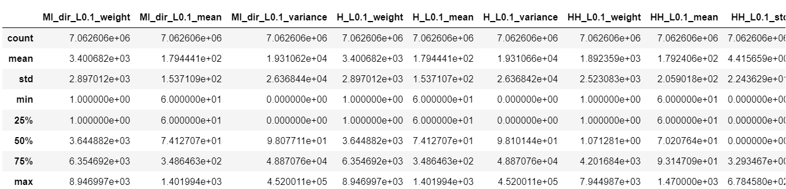Figure 10.2: Dataset Description
This figure shows the descriptive statistics of the dataset, including measures such as count, mean, standard deviation, min, and max values for each feature. It offers insights into the range and distribution of data points.
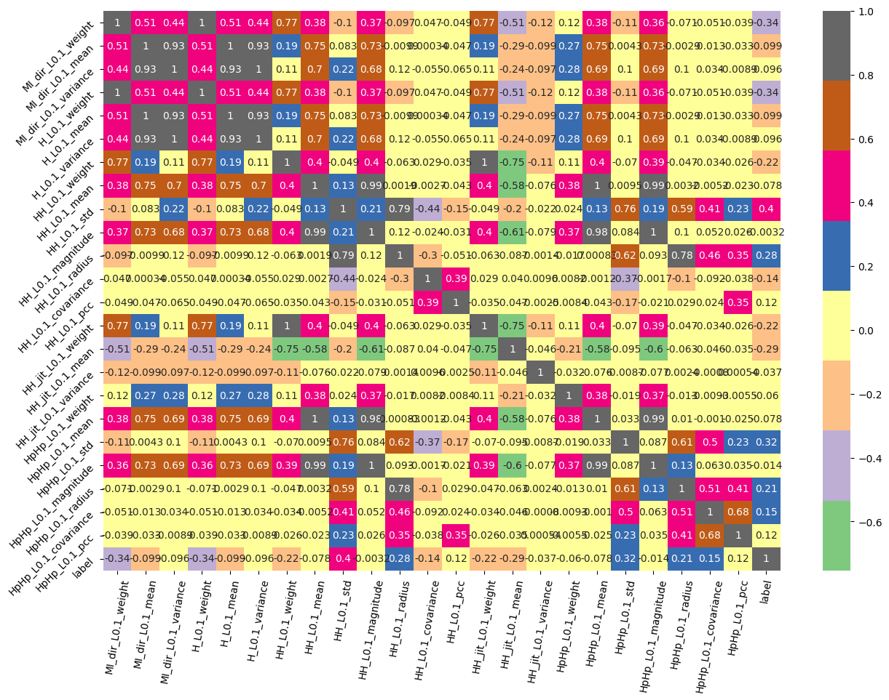Figure 10.3: Correlation Heatmap
This heatmap illustrates the correlation between different features in the dataset. The color gradient indicates the strength and direction of correlations, helping to identify which features are most related to each other.
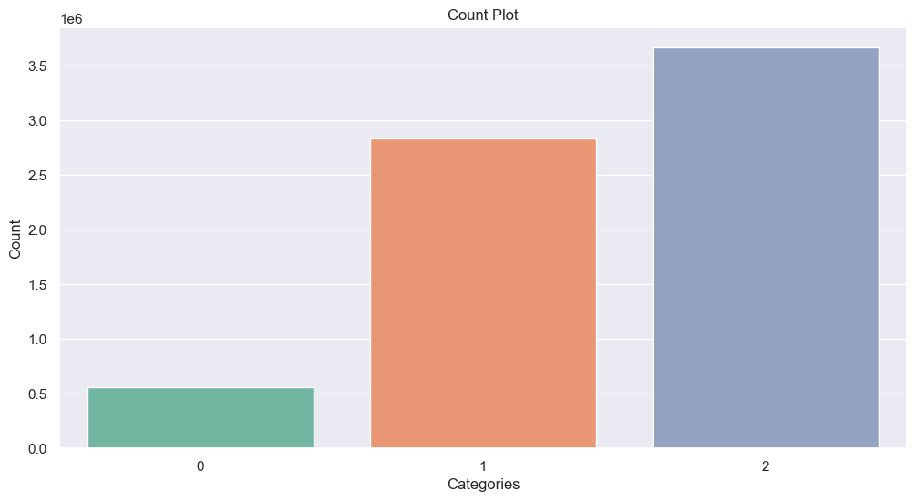Figure 10.4: Count Plot of Attack Categories
This count plot visualizes the distribution of different attack categories in the dataset. It shows the number of instances for each class: Normal, BASHLITE, and Mirai.
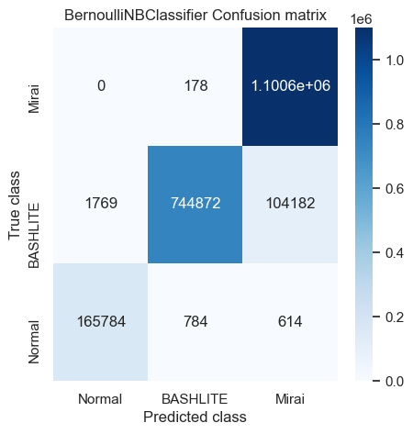
Figure 10.5: Confusion Matrix of Bernoulli Naive Bayes Classifier
This confusion matrix displays the performance of the Bernoulli Naive Bayes Classifier on the test data. It shows the number of true positives, false positives, true negatives, and false negatives for each class.
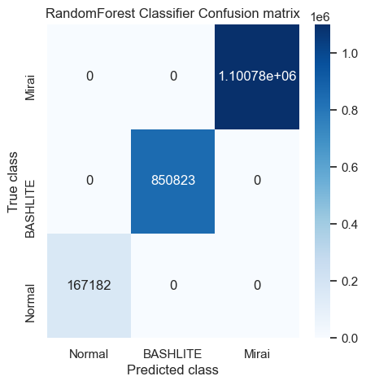
Figure 10.6: Confusion Matrix of Random Forest Classifier
This figure presents the confusion matrix for the Random Forest Classifier. It provides a detailed breakdown of the classifier's performance, highlighting the correct and incorrect predictions for each attack category.
Figure 10.7: Prediction on New Test Data (First 15 Rows)
This figure presents the predictions made by the Random Forest Classifier on new test data, specifically for the first 15 rows. It shows the predicted class for each instance and the corresponding actual values for comparison.
CHAPTER 11
CONCLUSION AND FUTURE SCOPE
11.1 CONCLUSION
This project successfully demonstrates the application of machine learning techniques to enhance the detection of sophisticated IoT-based botnet attacks. By leveraging the Bernoulli Naive Bayes and Random Forest classifiers, the framework addresses the challenges posed by the increasing volume and complexity of network traffic due to the proliferation of IoT devices.
The implementation focuses on two prevalent botnets, Mirai and BASHLITE, which have historically exploited vulnerabilities in IoT devices to orchestrate large-scale Distributed Denial of Service (DDoS) attacks and other cyber threats. The use of machine learning enables the system to identify anomalous patterns in network traffic, which traditional rule-based systems might overlook. The Random Forest classifier, in particular, provides a high degree of accuracy and robustness, making it a suitable choice for real-world deployment in dynamic network environments.
This AI-driven approach offers significant improvements over manual inspection and traditional anomaly detection methods. The ability to process and analyze vast amounts of data in real time, coupled with the adaptability of machine learning models to evolving attack patterns, ensures that the framework remains effective even as cyber threats become more sophisticated. Additionally, the integration of performance metrics like accuracy, precision, recall, and F1-score provides a comprehensive evaluation of the models, ensuring they meet the necessary standards for deployment.

11.2 FUTURE SCOPE
1.Integration with RealTime Systems:
One of the primary future directions for this project is to integrate the trained machine learning models into real-time network monitoring systems. This would involve deploying the models within network security infrastructures to continuously monitor and analyze incoming traffic for anomalies, providing instant alerts and automated responses to potential threats. Real-time deployment would also require optimizing the models for speed and efficiency, ensuring minimal latency in detection.
2.Incorporating Advanced Machine Learning Techniques:
While Bernoulli Naive Bayes and Random Forest classifiers provide a solid foundation, future enhancements could explore more advanced machine learning techniques, such as deep learning. Convolutional Neural Networks (CNNs) or Recurrent Neural Networks (RNNs) could be employed to capture more complex patterns in network traffic data, potentially improving detection rates for sophisticated or novel attack vectors.
3. Expanding the Scope to Include Other Botnets:
The current framework focuses on detecting Mirai and BASHLITE botnets. Future work could expand the scope to include other emerging IoT botnets, such as Hajime, Amnesia, or Reaper. By incorporating a broader range of attack types, the framework could be made more versatile and capable of handling a wider array of threats.
4. Feature Engineering and Dimensionality Reduction:
Further exploration into feature engineering could enhance the model’s performance. Techniques like Principal Component Analysis (PCA) or t-SNE could be employed to reduce dimensionality, enabling the models to focus on the most critical features while reducing computational overhead. Additionally, the exploration of new features, derived from more granular network traffic data, could improve the model's ability to distinguish between normal and malicious traffic.
5. Addressing Data Imbalance and Improving Model Generalization:
Given the nature of cyber attack datasets, there is often a significant imbalance between normal and anomalous traffic. Future work could involve the implementation of more sophisticated data balancing techniques, such as Synthetic Minority Over-sampling Technique (SMOTE) or Adaptive Synthetic (ADASYN), to enhance model training. Additionally, techniques like cross-validation could be employed to improve model generalization and reduce overfitting.
6. Adaptive Learning and model Updating:
As cyber threats evolve, it is crucial for detection systems to adapt over time. Future developments could include the integration of adaptive learning mechanisms, allowing the model to update itself as new data becomes available. This could involve periodic retraining of the model or the implementation of online learning techniques, where the model continuously learns from new network traffic data without needing a complete retraining cycle.
7. Collaborative Threat Intelligence:
Another potential area for future development is the integration of collaborative threat intelligence. By sharing anonymized network traffic patterns and attack signatures across different organizations, the framework could benefit from a broader knowledge base, improving its ability to detect and respond to emerging threats. This could be facilitated through secure, decentralized platforms that allow for the exchange of threat data while maintaining privacy and confidentiality.
8. Compliance and Ethical Considerations:
As the framework is developed further, attention should be given to ensuring compliance with cybersecurity regulations and ethical considerations. This includes ensuring that the system respects user privacy and data protection laws, as well as addressing any potential biases in the model that could lead to false positives or negatives.
9. User Interface and Visualization:
To make the system more user-friendly, future work could involve developing an intuitive user interface that allows network administrators to easily interpret the model’s predictions and gain insights into detected anomalies. Visualization tools, such as interactive dashboards and real-time alerts, could be integrated to provide a more comprehensive view of the network’s security status.

REFERENCES
[1] Abomhara, M.; Køien, G.M. Cyber security and the internet of things: Vulnerabilities, threats, intruders and attacks. J. Cyber Secur. Mobil. 2015, 4, 65–88.
[2] Andrea, I.; Chrysostomou, C.; Hadjichristofi, G. Internet of things: Security vulnerabilities and challenges. In Proceedings of the 2015 IEEE Symposium on Computers and Communication (ISCC), Larnaca, Cyprus, 6–9 July 2015; pp. 180–187.
[3] Deogirikar, J.; Vidhate, A. Security attacks in IoT: A survey. In Proceedings of the 2017 International Conference on I-SMAC (IoT in Social, Mobile, Analytics and Cloud) (I-SMAC), Palladam, India, 10–11 February 2017; pp. 32–37.
[4] Neshenko, N.; Bou-Harb, E.; Crichigno, J.; Kaddoum, G.; Ghani, N. Demystifying IoT security: An exhaustive survey on IoT vulnerabilities and a first empirical look on internet-scale IoT exploitations. IEEE Commun. Surv. Tutor. 2019, 21, 2702–2733.
[5] Ronen, E.; Shamir, A. Extended functionality attacks on IoT devices: The case of smart lights. In Proceedings of the 2016 IEEE European Symposium on Security and Privacy (EuroS&P), Saarbrücken, Germany, 21–24 March 2016; pp. 3–12.
[6] Alaba, F.A.; Othman, M.; Hashem, I.A.T.; Alotaibi, F. Internet of things security: A survey. J. Netw. Comput. Appl. 2017, 88, 10–28.
[6] McDermott, C.D.; Majdani, F.; Petrovski, A.V. Botnet detection in the internet of things using deep learning approaches. In Proceedings of the 2018 International Joint Conference on Neural Networks (IJCNN), Rio de Janeiro, Brazil, 8–13 July 2018; pp. 1–8.
[7] Brun, O.; Yin, Y.; Gelenbe, E. Deep learning with dense random neural network for detecting attacks against IoT-connected home environments. Procedia Comput. Sci. 2018, 134, 458–463.
[8] Meidan, Y.; Bohadana, M.; Shabtai, A.; Ochoa, M.; Tippenhauer, N.O.; Guarnizo, J.D.; Elovici, Y. Detection of unauthorized IoT devices using machine learning techniques. arXiv 2017, arXiv:1709.04647.
[9] Doshi, R.; Apthorpe, N.; Feamster, N. Machine learning DDoS detection for consumer internet of things devices. In Proceedings of the 2018 IEEE Security and Privacy Workshops (SPW), San Francisco, CA, USA, 24–24 May 2018; pp. 29–35.
[10] Sivaraman, V.; Gharakheili, H.H.; Vishwanath, A.; Boreli, R.; Mehani, O. Network-level security and privacy control for smart-home IoT devices. In Proceedings of the 2015 [11] IEEE 11th International Conference on Wireless and Mobile Computing, Networking and Communications (WiMob), Abu Dhabi, UAE, 19–21 October 2015; pp. 163–167.
[12] Yavuz, F.Y.; Devrim, Ü.N.A.L.; Ensar, G.Ü.L. Deep learning for detection of routing attacks in the internet of things. Int. J. Comput. Intell. Syst. 2018, 12, 39–58.
[13] Shiranzaei, A.; Khan, R.Z. An Approach to Discover the Sinkhole and Selective Forwarding Attack in IoT. J. Inf. Secur. Res. 2018, 9, 107.
[14] Soni, V.; Modi, P.; Chaudhri, V. Detecting Sinkhole attack in wireless sensor network. Int. J. Appl. Innov. Eng. Manag. 2013, 2, 29–32.
[15] Palacharla, S.; Chandan, M.; GnanaSuryaTeja, K.; Varshitha, G. Wormhole attack: A major security concern in internet of things (IoT). Int. J. Eng. Technol. 2018, 7, 147–150.

